**Isaiah Crace**

**Cumberland University**

**Something In Microcomputing**

**Mike Dillon**

**Feb 18, 2024**

*The Effects of A Bug Consuming Diet*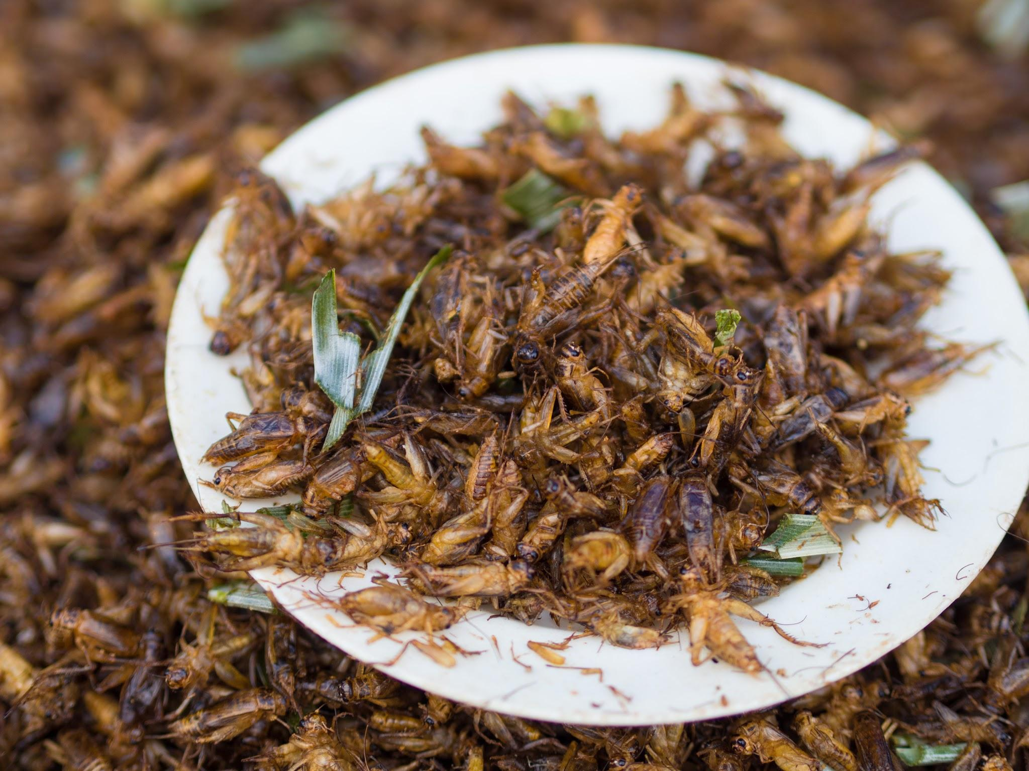

The effects of a bug consuming diet has been a staple of many cultures for a majority of their existence. Of course, in Western culture we don’t tend to eat these creatures, because we have interesting standards that food shouldn’t look like the creature it came from, and people nowadays tend to get grossed out by the thought that eating meat or some other form of animal product comes from just that; an *animal.* “In some societies, primarily western nations, entomophagy is uncommon or taboo.” (*Entomophagy*, n.d.).

With the eating of insects in the Western world rising to popularity in places like California and other hubs of commerce, trade and migration, eating insects starts to seem less and less disgusting than a lot of people might initially think. With the current worldwide crisis of food shortages growing ever more every day - not just in places like Haiti or Angolia, but all over the world, *including* but not limited to the Western world - bugs might very well be the future of what we dine on, if we continue the rate we’re going.

Growing about a billion more every few decades, the human population has steadily increased over the past 100 years, causing of course doomsday theorists to speculate that we may run out of food very soon. Evidently, that is not the case, but there is always some truth to even the craziest predictions. Food shortages, and food “deserts” across the globe have caused many issues for a lot of people for a very, very long time. Food deserts are areas where people live without good access to healthy food - because some people have great access to “food” - junk food like chips, candy, etc., but limited access to vegetables, meats, fruits, because of the price of lack thereof of the option.

Eating insects can also vastly improve our planet, especially since we already have issues with their overpopulation, and the land that we use for farming sometimes gets eaten by another potential and high in protein food source; insects[1] (Armas, 2021).

**References**

Wikimedia Foundation. (2023, December 3). *Entomophagy*. Wikipedia. <https://en.wikipedia.org/wiki/Entomophagy#:~:text=The%20scientific%20term%20describing%20the,3%2C000%20ethnic%20groups%20practice%20entomophagy>.

<https://www.citationmachine.net>

*Eating the right insects can provide nutrition ... and might be good for the planet*. www.heart.org. (2023, January 24). <https://www.heart.org/en/news/2021/10/22/eating-the-right-insects-can-provide-nutrition-and-might-be-good-for-the-planet>.

**Appendix**

* Word and other apps are still 30 years behind
* Corporate applications kinda suck
* It’s valuable to know for joining the workforce regardless

| **Names** | **Fun Fact** |
| --- | --- |
| Jevon Ballard | I don’t know who they are. |
| Ally Barnett | Shockingly, same as the first. |
|
| Jadyn Binkley | Three times in a row? Incredible. |

1. I changed this word from “bug” to “insect”.